**CHATBOT DEPLOYMENT WITH IBM CLOUD WATSON ASSISTANT**

**( PHASE : 5 )**

The chatbot streamlines IT support queries by automating the dialog flow. IBM Watson Assistant is a question-and-answer system that provides a dialog interaction between the conversation system and users. This style of interaction is commonly called a chatbot.

**How to build a better chatbot?**

Chatbots powered by IBM Watson Assistant can do much more than just chat – they offer quick, accurate answers across digital and voice channels, and are able to complete complex transactions by leveraging robotic process automation and backend integrations with business systems.Watson Assistant is underpinned by Large Language Models (LLMs) and comes with out-of-the-box natural language processing, which can address the messy nature of human communication and prevent conversations from reaching a frustrating dead-end.

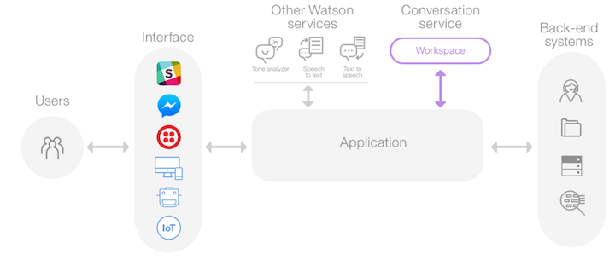

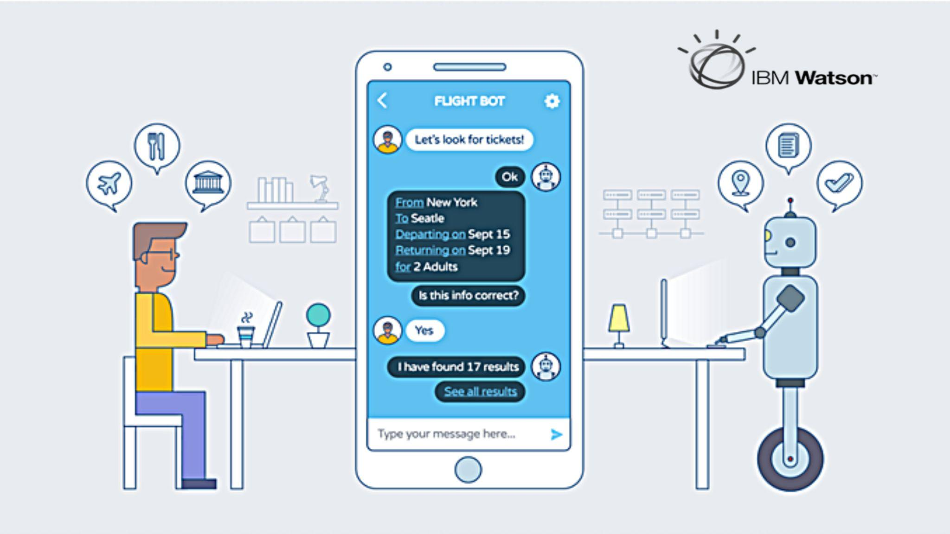

IBM Watson Assistant is a market-leading, conversational artificial intelligence platform designed to help you overcome the friction of traditional support and deliver exceptional experiences to prospects, customers, and employees.

Powered by large language models (LLMs) you can trust, and an intuitive user interface, Watson Assistant empowers your teams to build AI-powered voice agents and chatbots that deliver automated self-service support across all channels and touch-points with seamless integration to the tools that power your business.

**Problem Definition:**

The project involves creating a chatbot using IBM Cloud Watson Assistant. The primary objective is to develop a virtual guide capable of assisting users on messaging platforms such as Facebook Messenger and Slack. This chatbot should offer valuable information, address frequently asked questions (FAQs), and provide a friendly and engaging conversational experience. The project encompasses various aspects, including defining the chatbot's persona, configuring responses, integrating with messaging platforms, and ensuring a seamless user experience.

**Design Thinking Approach:**

**1. Persona Design: Name:** We will create a name for our chatbot, which should resonate with the target audience. The name should be friendly and approachable [NAME : NMBOT]

**2.Tone and Style of Communication:** Determine the chatbot's tone of communication, whether it should be formal, informal, humorous, or professional. The style of communication should align with the chatbot's persona and user expectations.

**3. User Scenarios:** Identify common user scenarios and FAQs that the chatbot should be capable of addressing. This step involves understanding the potential user needs and pain points. Some examples of user scenarios might include: - User wants to know business hours. - User is looking for product information. - User needs assistance with account login.

**4. Conversation Flow:**

Design the conversation flow to outline how the chatbot will respond to user queries and prompts. This involves creating a flowchart or decision tree that maps out different user interactions and the chatbot's responses. Consider branching logic for handling various scenarios effectively.

**5. Response Configuration:** Configure the chatbot's responses using Watson Assistant's intents, entities, and dialog nodes. Define intents that represent user queries and entities to extract important information from user input. Create dialog nodes to structure the conversation and specify how the chatbot should respond based on detected intents and entities.

**6. Platform Integration:** Integrate the chatbot with popular messaging platforms like Facebook Messenger and Slack. This step involves leveraging the respective APIs and ensuring seamless connectivity. We'll also need to adapt the chatbot's responses and interactions to the specific platform's capabilities and user expectations.

**7. User Experience:** Prioritize user experience by focusing on the following: Clear Prompts: Ensure that the chatbot provides clear and concise prompts to guide users through interactions.

**8.Informative Responses:** The chatbot should offer informative and relevant responses that genuinely address user queries or concerns.

**9.Error Handling:** Implement error handling mechanisms to gracefully handle user input that the chatbot cannot understand or process.

**10.Personalization:** Consider personalization options to make the interaction more engaging and tailored to individual user preferences.

**11.Feedback Loop:** Establish a feedback loop for continuous improvement, allowing users to provide feedback on the chatbot's performance and suggestions for enhancement.

By following this design thinking approach, we aim to create an effective and user-friendly chatbot that not only addresses user needs but also provides a delightful conversational experience. This phase lays the foundation for the subsequent stages of chatbot development and deployment.

**Project Objectives:**

● Deploy the chatbot created using IBM Cloud Watson Assistant to production environments.

● Ensure the chatbot is accessible on messaging platforms such as Facebook Messenger and Slack.

● Optimize the chatbot for performance and scalability.

● Implement monitoring and maintenance procedures to ensure the chatbot's ongoing success.

Deployment Plan

**1. Environment Setup**

● **Development Environment:** We have used IBM Cloud watson assistant platform to deploy our chatbot

Production Environment

**1. Server Configuration:** The production environment will consist of multiple virtual servers to distribute the workload and ensure redundancy. The server configuration will include:

2. Server Type:Virtual Machines (VMs) with suitable CPU, RAM, and storage resources.

3. Operating System: Linux-based operating system (e.g., Ubuntu, CentOS) will be used for server instances.

4. Load Balancer:A load balancer will be implemented to distribute incoming traffic evenly across multiple server instances, enhancing performance and fault tolerance.

**2. Deployment Steps**

**Step 1:** Pre-deployment Testing

Objective: Ensure that the chatbot functions as expected before deployment. Activities:

- Conduct thorough testing of the chatbot's responses and interactions.

- Verify that the chatbot handles various user scenarios effectively

- Identify and resolve any issues or bugs.

**Step 2:** Integration with Messaging Platforms

Objective: Integrate the chatbot with messaging platforms like Facebook Messenger and Slack.

Activities:

- Configure platform-specific integration settings.

- Test the chatbot's functionality on each platform.

- Ensure proper authentication and permissions are in place.

**Step 3:** Performance Optimization

Objective: Optimize the chatbot's performance for responsiveness and efficiency.

Activities:

- Review and optimize chatbot code and responses for speed.

- Implement caching mechanisms if necessary.

- Optimize database queries if applicable.

**Step 4:** Security and Data Privacy

Objective: Ensure that user data and interactions are secure and comply with data privacy regulations.

Activities:

- Implement encryption for data transmission.

- Secure access to chatbot APIs and databases.

- Review and update privacy policies.

**Step 5:** Monitoring and Analytics

Objective: Set up monitoring and analytics tools to track chatbot performance.

Activities:

- Implement monitoring for server health and response times.

- Set up error tracking and logging.

- Configure analytics to gather user interaction data

**Step 6:** User Documentation

Objective:Create user documentation to guide users on how to interact with the chatbot.

Activities:

- Develop user guides and FAQs.

- Provide clear instructions on how to access and use the chatbot.

**Step 7:** Deployment to Production

Objective:Deploy the chatbot to the production environment for public access.

Activities:

- Coordinate deployment with IT or DevOps teams.

- Monitor the deployment process for any issues.

- Perform final testing in the production environment.

3. Post-Deployment Tasks

**Step 8:** User Training and Support

Objective: Provide training and support to users who will interact with the chatbot.

Activities:

- Conduct training sessions for end-users.

- Establish channels for user support and assistance.

**Step 9:** Ongoing Maintenance

Objective: Implement maintenance procedures to ensure the chatbot's continued functionality and improvement.

Activities:

- Schedule regular updates and bug fixes.

- Monitor user feedback and make necessary adjustments.

- Stay informed about updates to IBM Cloud Watson Assistant.

**Step 10:** Performance Monitoring

Objective: Continuously monitor chatbot performance and user interactions

Activities:

- Monitor system resources, response times, and error rates.

- Analyze user behavior and interactions.

- Use analytics data to refine the chatbot's responses.

**Key Features:**

Natural Language Understanding (NLU) The primary advanced feature in this project is Natural Language Understanding (NLU).

With NLU, the chatbot can:

- Recognize user intents and context with high accuracy.

- Extract entities and relevant information from user input.

- Enhance user interactions by providing more relevant and context-aware responses.

**Success Criteria:**

The success of the project will be evaluated based on the following criteria: 1**. Improved User Intent Recognition:**

The chatbot should exhibit a significant increase in accuracy in recognizing and responding to user intents.

**2. Enhanced User Experience:**

User feedback and satisfaction scores should indicate an improved chatbot experience.

**3. Reduced Escalation:**

The number of interactions requiring human intervention should decrease.

In IBM Watson Assistant, which is a cloud-based conversational AI platform, entities, intents, and dialogs are key components used to build and train chatbots or virtual assistants. Here's a brief explanation of each:

Entities:

• In Watson Assistant, an entity represents a specific piece of information within user input. It is used to extract relevant data from user messages. Entities can be things like dates, numbers, product names, or any other data you want to capture. You define entities to help the assistant understand and process user queries more effectively.

• For example, if you're building a chatbot for a restaurant, you might define an entity named "cuisine" to extract the type of cuisine the user is interested in (e.g., Italian, Chinese, Mexican).

Intents:

• An intent is the purpose or goal expressed in a user's message. It represents what the user is trying to achieve or communicate. Intents are essential for routing user requests to the appropriate responses or actions. You define intents to help the assistant recognize and categorize user input accurately.

• For instance, in a virtual assistant for a bank, you might define intents like "Check Account Balance," "Transfer Funds," or "Report Lost Card" to identify the user's intentions.

**Dialogs:**

• Dialogs in Watson Assistant are used to structure the conversation flow between the user and the chatbot. You create dialog nodes to define how the assistant should respond to user input based on detected intents and entities. Dialogs help in creating dynamic and context-aware interactions.

• Within a dialog node, you can define responses, conditions, and actions to take. You can also incorporate variables to store and retrieve information throughout the conversation, enabling personalized interactions.

➢ The typical workflow in Watson Assistant involves defining entities and intents, building dialog nodes to handle different conversation paths, and training the assistant using historical data or sample conversations. This training helps the assistant understand user input better, recognize intents and entities accurately, and respond appropriately.

➢ Entities, intents, and dialogs work together to enable natural and context-aware conversations between users and your chatbot or virtual assistant built with IBM Watson Assistant. By correctly defining and configuring these components, you can create effective and intelligent conversational interfaces.

➢ Now we are going to create the chatbot for that we will do the primary steps now.

**STEP1:**

• Login To The IBM account and click on the Catalog and then search for Watson Assistant and enter.

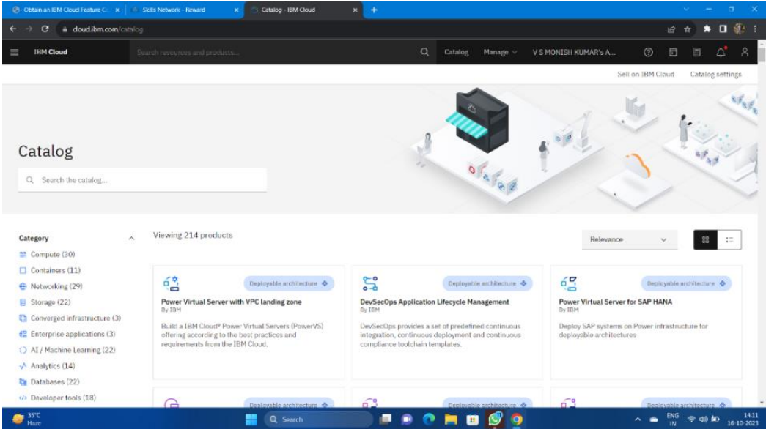

• You will get the Watson Assistant There By default you will have this

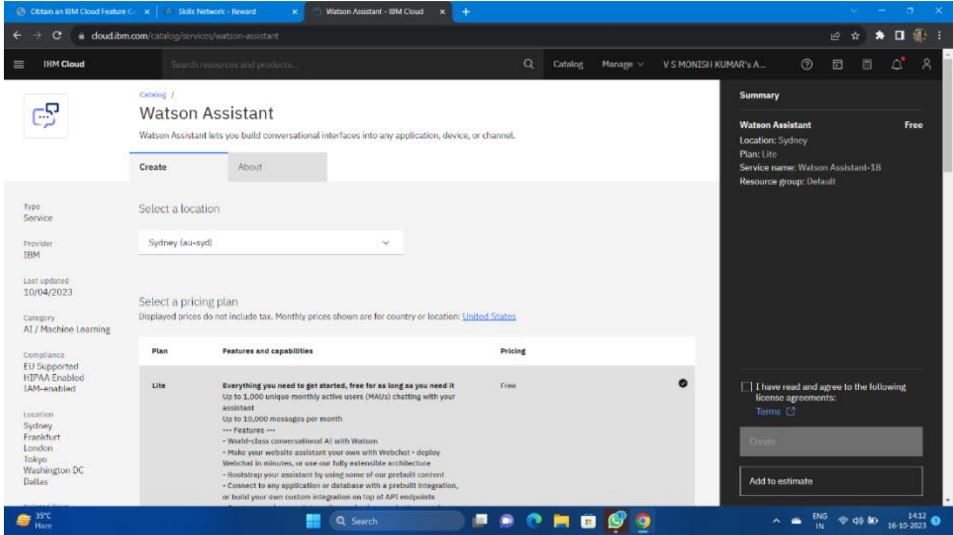

**Step 2:**

• Change the default location and give the location as London(eu-gb) and select the plan as Lite

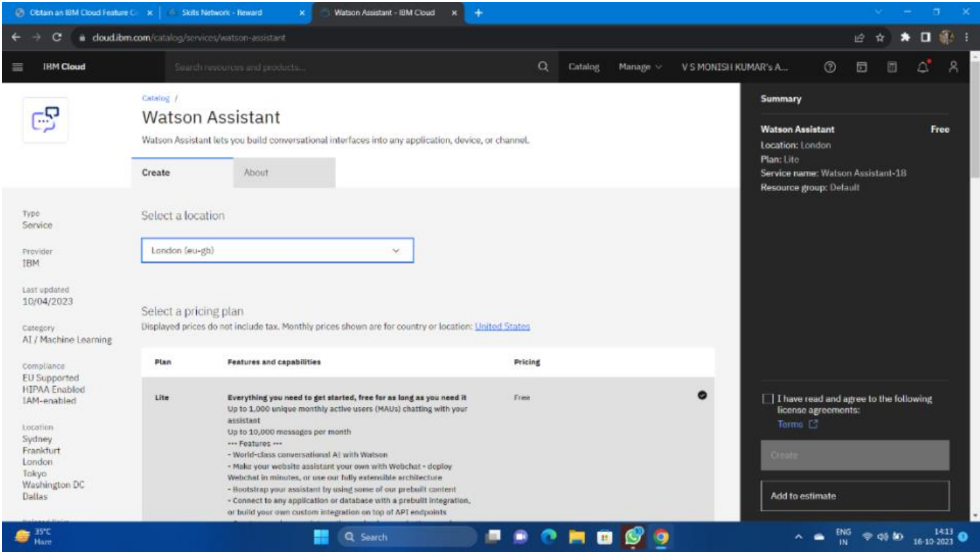

• Give tick mark for I have read and agree to the following license agreement • Now click on create it will create an instance for you

**Step 3:**

• After creating an instance for Watson Assistant you need to launch the Watson Assistant by clicking the launch the assistant

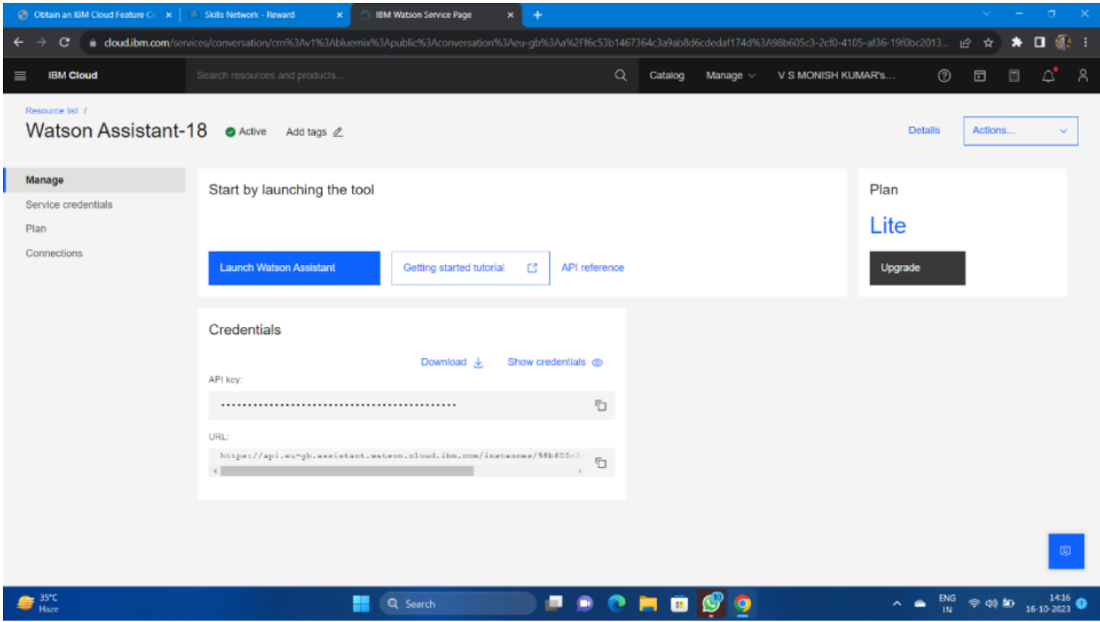

**Step 4:**

• It will give the access to create the assistant give the name for the Assistant and give the description for that assistant it's completely optional click on create and save it.

• Here I have been created NM BOT as my chat bot assistant name .

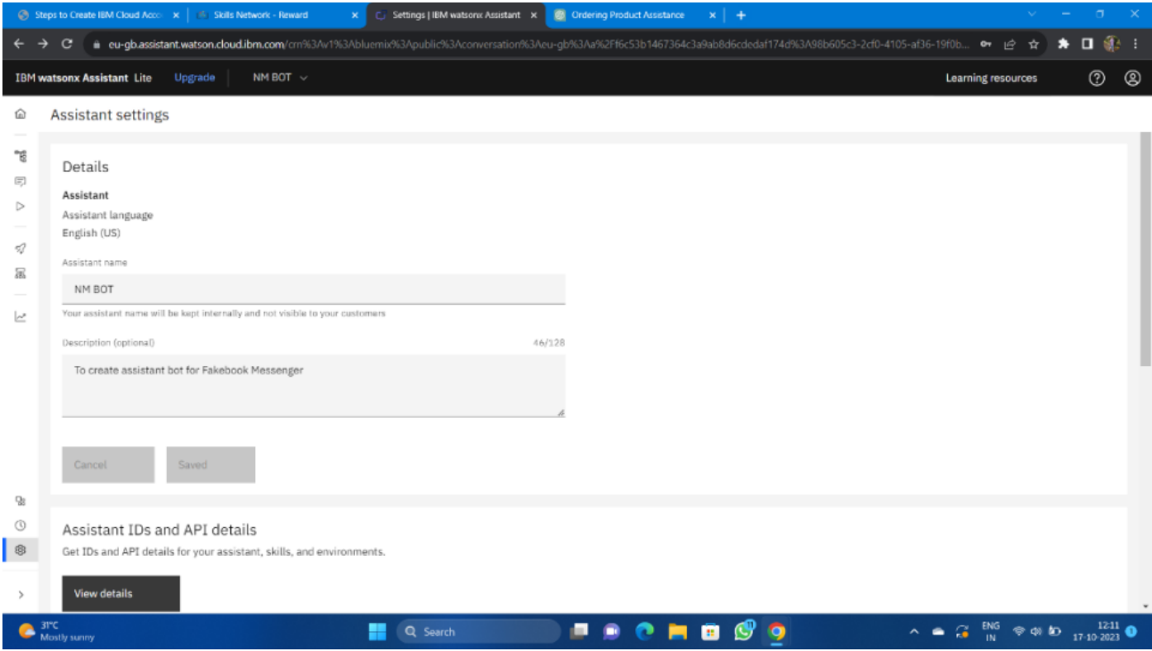

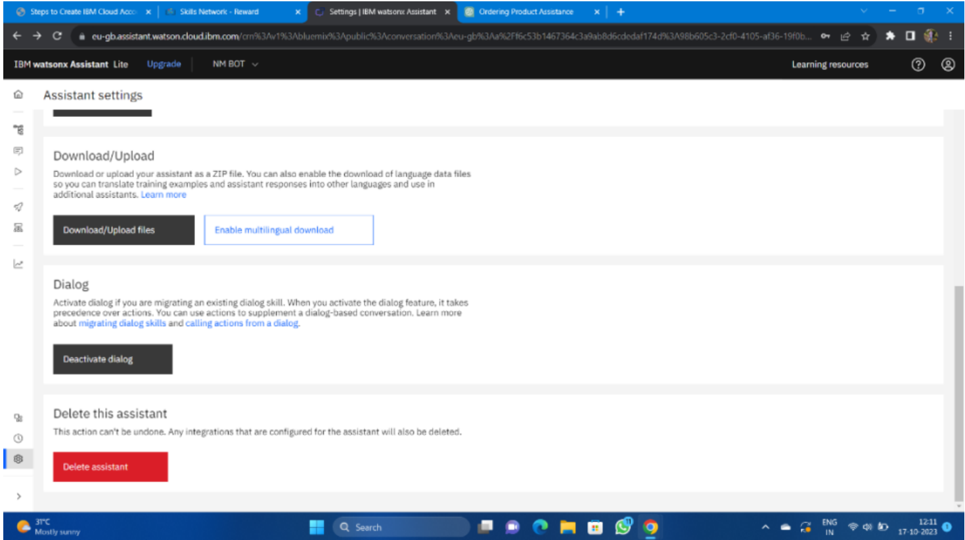

**Step 5:**

• After activating the Dialog, you will get the Intents, Entities, Dialog, and Content catalog like shown below

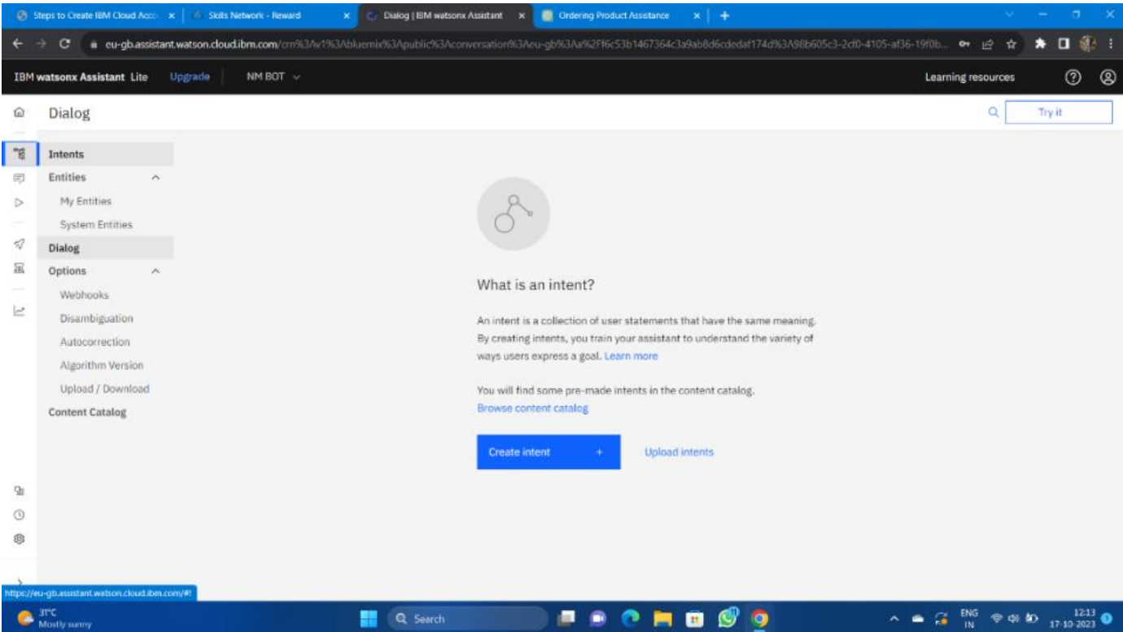

**Step 6:**

• Create the Entities first and one variable for the entities you have been created.

• Here I have created the Entity with the name Entertainment and added variables as channels and stars with some variable value.

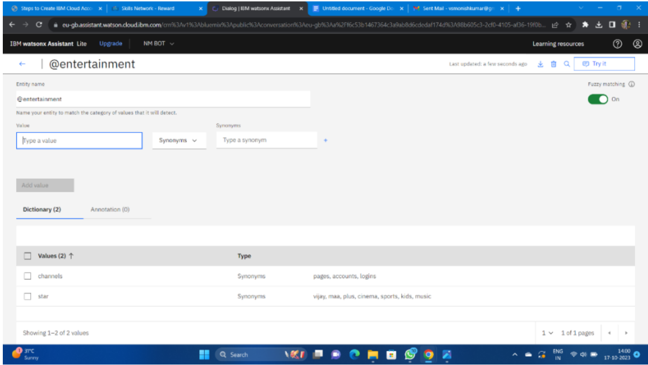

**Step 7:**

• Open the Intents and then create the Intents for Messages, Services, AboutMe give some example queries for them

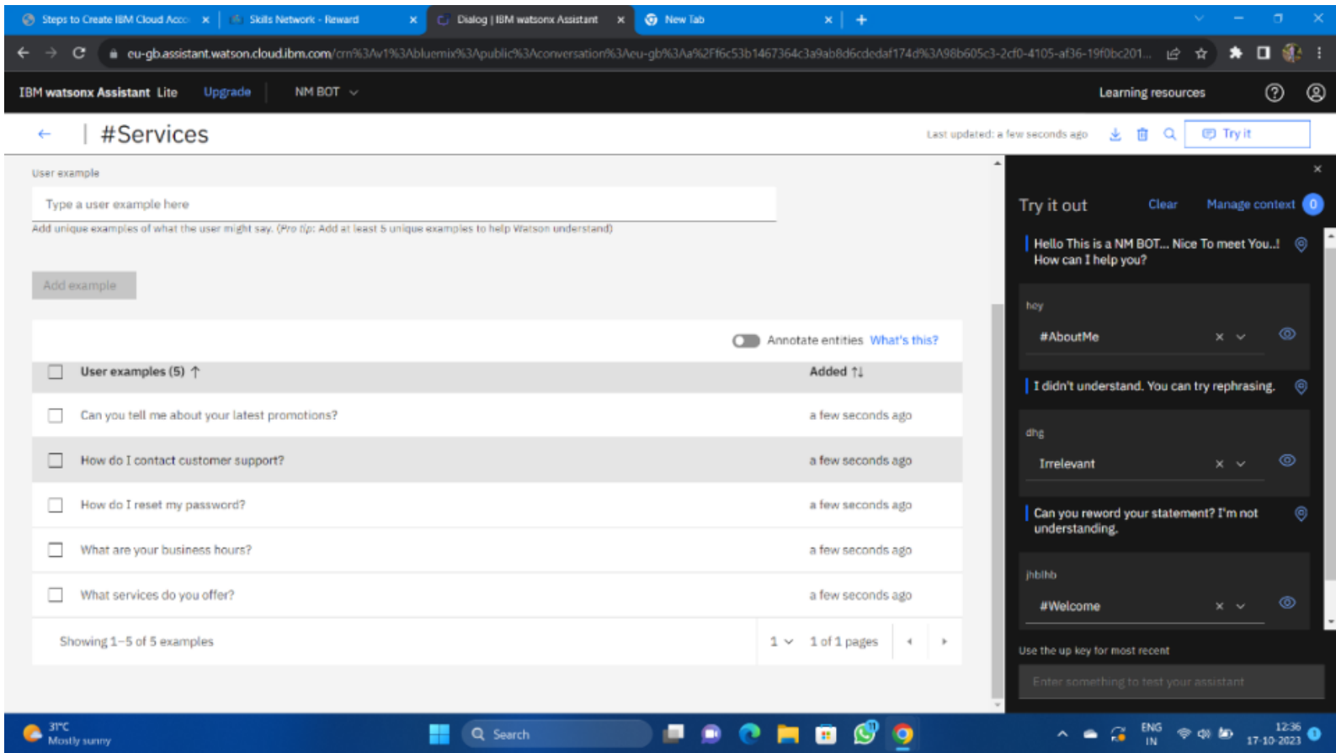

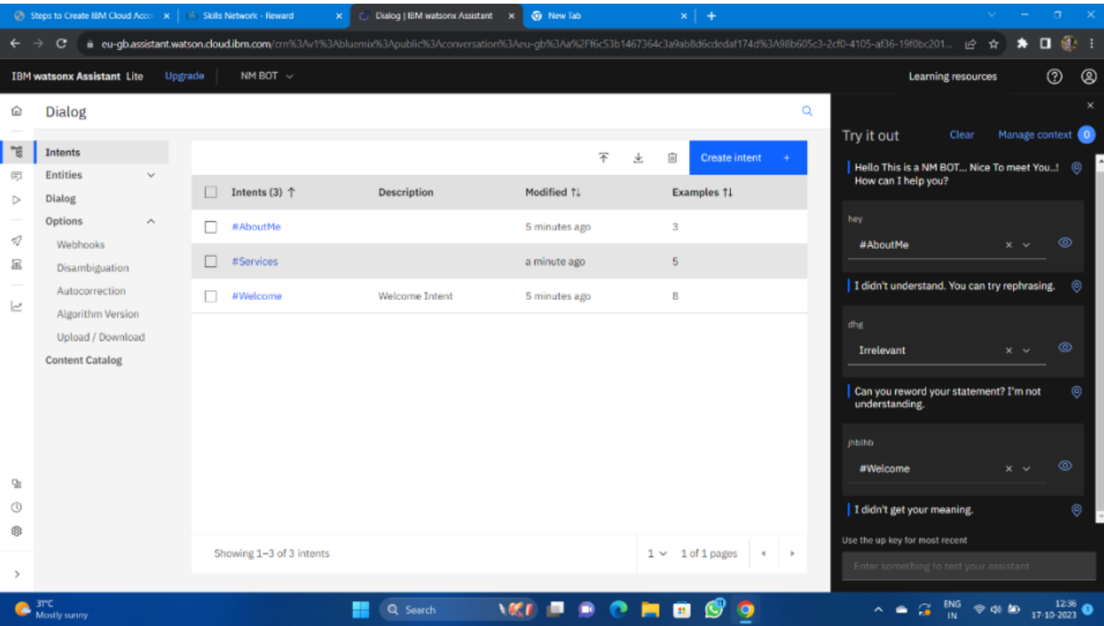

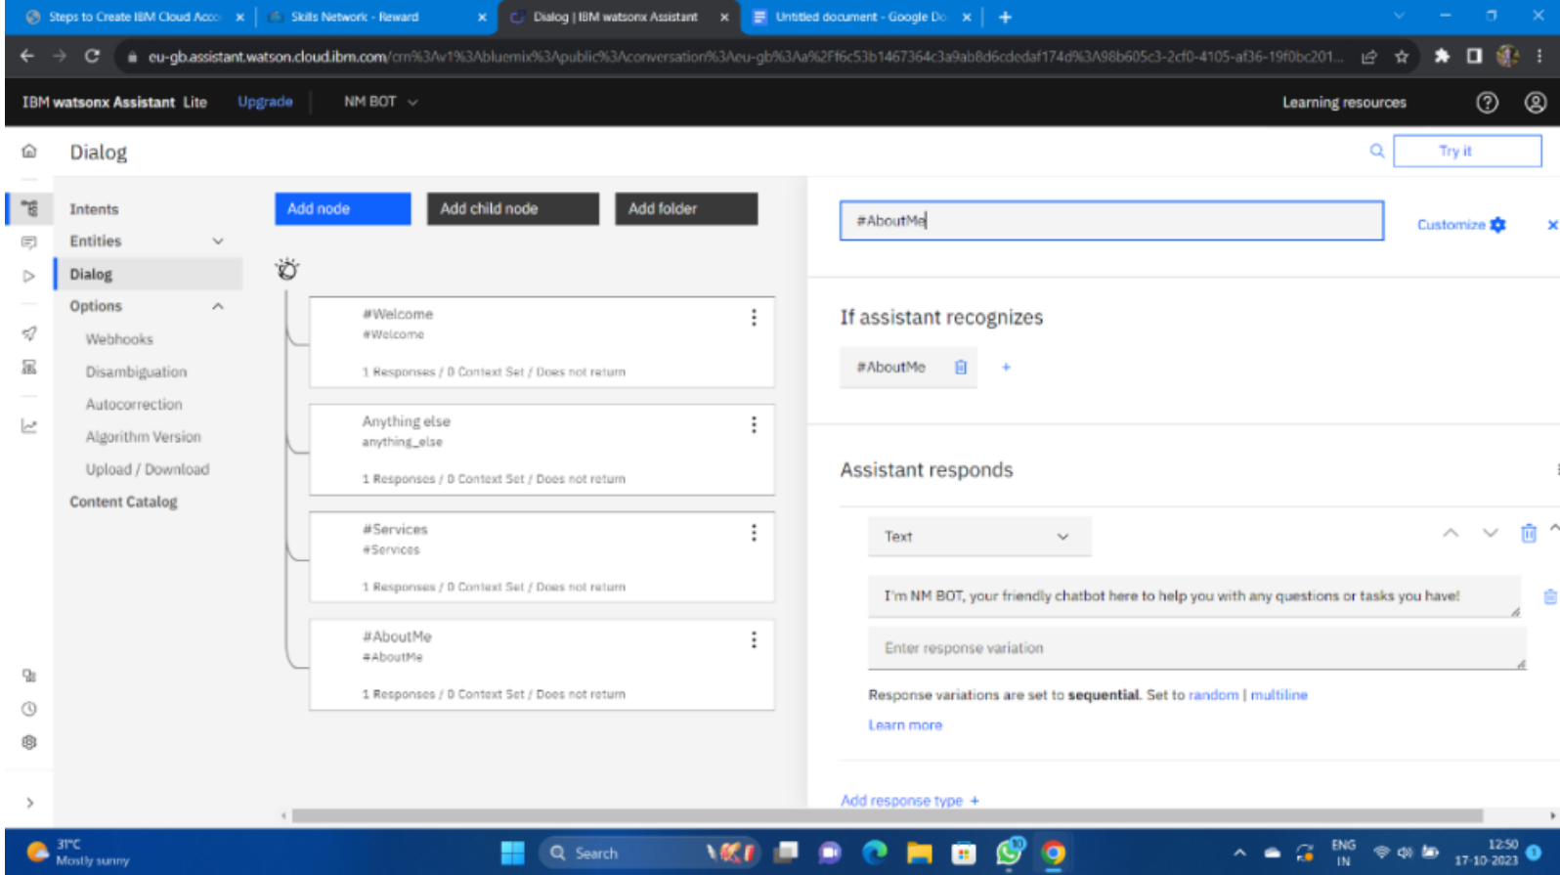

**Step 8:**

• Next open the Dialog and then add nodes for all the Intents you have created where we need to give the responses for the selected queries.

• Whereby default we will have Anything else node.

**Step 9:**

• Check the chat bot by clicking the try it before connecting the Facebook Messenger.

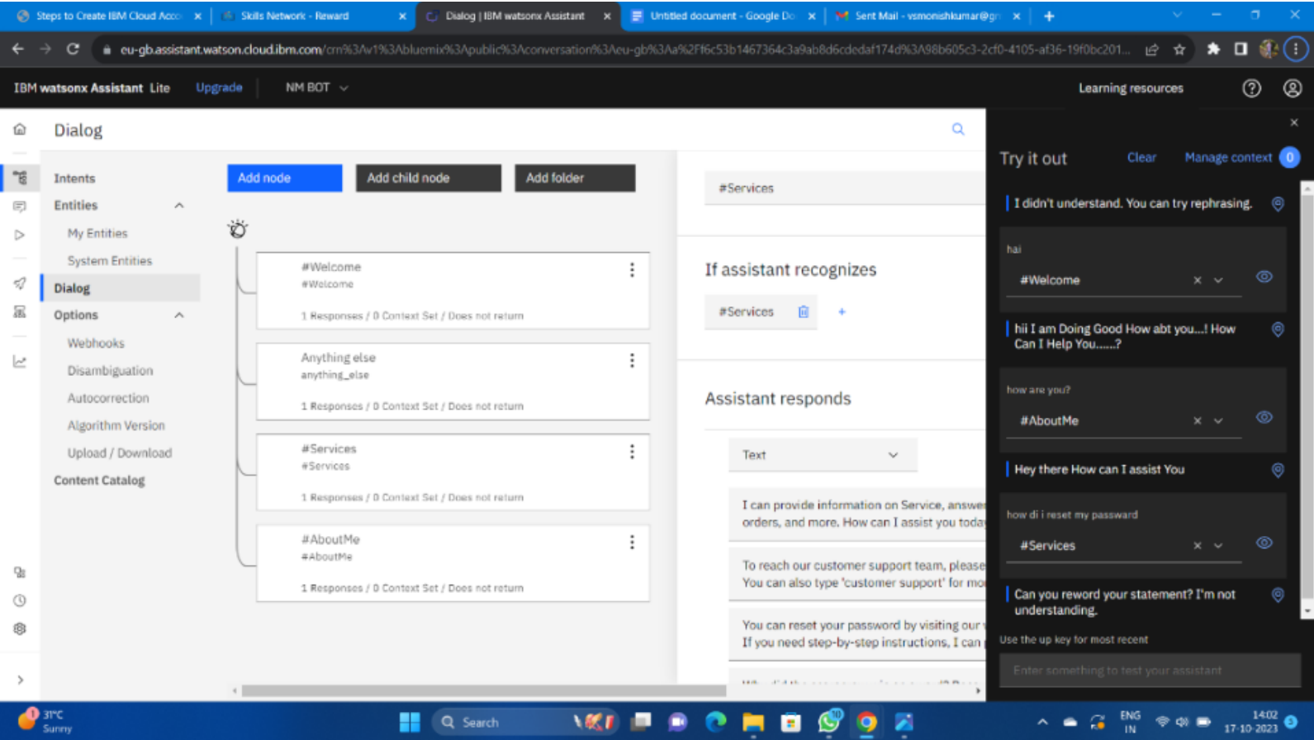

Integrating the chatbot with Facebook Messenger and Slack using respective APIs.

Initially go to IBM and login and then go to the already existing Watson instance and then open it and launch the assistance. It shows an already existing bot that we created in the before phase, open the home page in it and then start connecting the channels.

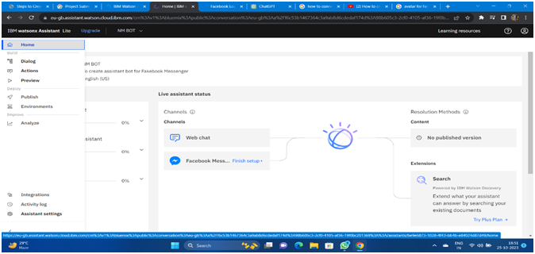

**Step 1:** Create a Facebook Page

Log in to your Facebook account.

Go to Facebook's Create a Page and follow the steps to create a Facebook Page. This Page will be used to host your chatbot.

**Step 2:** Set Up a Facebook App

Go to the Facebook for Developers website.

Create a new app by clicking on "My Apps" and then "Create App."

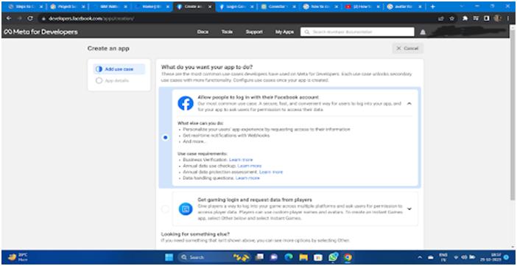

**Step 3:** Configure the Facebook App for Messenger

In your Facebook App dashboard:

a. Go to the "Messenger" section.

b. Under "Access Tokens," generate a Page Access Token. You'll need this token to connect your Watson Assistant to Facebook Messenger.

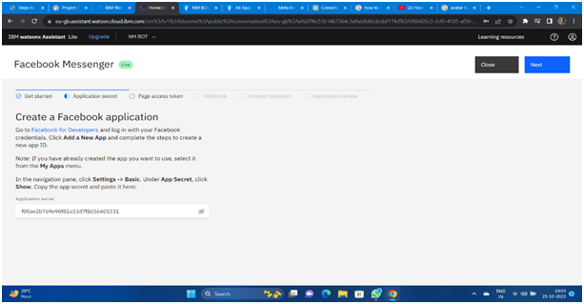

**Step 4:** Create or Access IBM Watson Assistant

If you don't have an instance of IBM Watson Assistant, you can create one on the IBM Cloud.

**Step 5:** Configure Watson Assistant

In your IBM Watson Assistant instance:

a. Create a new assistant or use an existing one

b. Configure your assistant by adding intents, entities, and dialog flows that suit your chatbot's purpose.

(Note: Step4 and Step5 already completed in phase 3 )

**Step 6:** Integrate Watson Assistant with Facebook Messenger

In the Watson Assistant Dashboard:

a. Go to the "Skills" section.

b. Add a new skill or use an existing one.

c. In the skill settings, go to the "Integrations" tab.

d. Click on "Facebook Messenger."

**Step 7:** Set Up the Webhook

In the Watson Assistant integration settings for Facebook Messenger:

a. Enter the Facebook Page Access Token you obtained in Step 3.

b. Specify the Webhook URL. This URL should be the same as the callback URL you set up in the Facebook App's Webhook settings.

c. Save the changes.

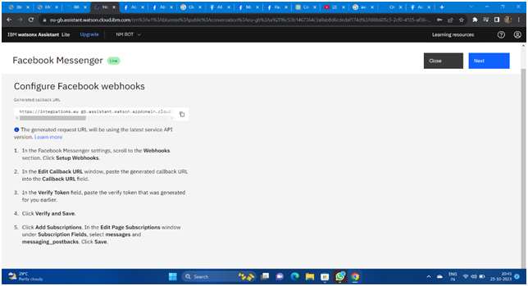

**Step 8**: Subscribe to the Facebook Webhook

In the Facebook App settings:

a. In the "Webhooks" section, click on "Edit Subscription."

b. Select the Facebook Page you created in Step 1.

c. Subscribe your Page to the webhook events.

After completing all the steps complete it and click finish the connection now your bot is connected with the facebook messenger.

**Chatbot's persona,conversation flow and technical implementation:**

**Persona:**Watson Assistant can have a persona that is defined by the developers or businesses using it. The persona can be tailored to match the brand's identity, tone, and style. For example, it can have a friendly, professional, or casual tone, depending on the use case and audience.

**Conversation Flow:**Watson Assistant's conversation flow is designed using a combination of intents, entities, and dialog nodes. Intents represent the user's intentions or what they want to accomplish. Entities are used to extract specific information from user inputs, such as dates, names, or locations.

Dialog nodes define the structure and responses of the conversation. They are organized in a tree-like structure to guide the conversation.

**Technical Implementation:**Watson Assistant is typically implemented using IBM Cloud services and provides RESTful APIs for integration into various platforms, such as websites, mobile apps, and messaging platforms.

**A simplified technical overview of implementing Watson Assistant:**

* **Training Data**: Developers input training data, including intents, entities, examples of user queries, and desired responses.
* **Training**: Watson Assistant uses this training data to train its natural language understanding (NLU) model.
* **Integration**: Watson Assistant can be integrated into applications and platforms using APIs or SDKs.
* **Communication**: Users interact with the chatbot through the integrated interface (e.g., a chat widget on a website or a messaging platform).
* **Understanding User Inputs**: When a user submits a query, Watson Assistant uses NLU to understand the intent and entities in the input.
* **Responses**: The chatbot generates responses and returns them to the user.
* **Learning**: Watson Assistant can learn from user interactions to improve its understanding and responses over time.

**Examples of user queries and the chatbot's responses:**

**User Query**: "What is the weather like in New York City today?"Chatbot Response: "I'm sorry, but I don't have access to real-time information. You can check the weather in New York City by using a weather website or app like Weather.com or checking your smartphone's weather app."

**User Query**: "Can you tell me a joke?"

**Chatbot Response**: "Sure! Why don't scientists trust atoms? Because they make up everything!"

**User Query:** "Explain the concept of global warming."

**Chatbot Response**: "Global warming refers to the long-term increase in Earth's average surface temperature due to the buildup of greenhouse gases in the atmosphere. These gases, such as carbon dioxide and methane, trap heat from the sun and cause the planet's temperature to rise, leading to various environmental and climate-related changes."

**User Query**: "What is the capital of France?"

**Chatbot Response**: "The capital of France is Paris."

**User Query**: "Tell me about the life of Albert Einstein."

**Chatbot Response**: "Albert Einstein was a renowned physicist who was born on March 14, 1879, in Ulm, Germany. He is best known for his theory of relativity, with the famous equation E=mc^2. Einstein made significant contributions to the field of theoretical physics and won the Nobel Prize in Physics in 1921. He passed away on April 18, 1955, in Princeton, New Jersey."

**User Query**: "How does photosynthesis work?"

**Chatbot Response**: "Photosynthesis is the process by which green plants, algae, and some bacteria convert sunlight, carbon dioxide, and water into glucose (a form of sugar) and oxygen. This process takes place in the chloroplasts of plant cells and relies on the pigment chlorophyll to capture sunlight and convert it into chemical energy, which is used for the plant's growth and maintenance."

**CONCLUSION:**

The successful deployment of the chatbot with IBM Cloud Watson Assistant marks a significant milestone in our project. It represents the culmination of meticulous planning, development, and deployment efforts. Our team has worked diligently to ensure that the chatbot is a valuable asset to our users and meets their needs effectively.

The production environment established for deployment is robust, secure, and scalable, providing a strong foundation for the chatbot's operation. Security measures have been implemented to safeguard user data, and monitoring procedures are in place to ensure high availability and performance.